**SRS Document For E-Commerce Shopping Cart System**

**ABSTRACT**:  
The E-Commerce Shopping Cart System is a Java console application designed to provide a seamless online shopping experience. This system allows users to register, browse products, add items to a cart, apply discount codes, and complete orders through an integrated payment processing simulation. The application leverages Object-Oriented Programming (OOP) principles, including inheritance, to create a modular and extensible design. JDBC is utilized for database management, handling product, user, order, and payment data. Additionally, file handling supports logging for transaction tracking and auditing. The intuitive user interface offers a comprehensive set of features, enabling both user and admin roles to interact with the system effectively.

**Key Components and Requirements**:

1. **Product Class**: Represents various product types, with attributes like product_id, name, category, price, and stock_quantity.
2. **User Class**: Manages user details (e.g., username, password, email, and role). Role-based functionality enables regular users to shop while granting admins control over product management.
3. **Shopping Cart and Order Management**: Manages the shopping cart, allowing users to add, remove, and view items before checkout. The Order class manages order details, including user information, order status, payment method, and order total.
4. **Discount and Payment Modules**: Applies discount codes during checkout for eligible orders. The payment module simulates various payment methods and updates order statuses upon successful payment.
5. **Device Management Interface**: Defines core methods for e-commerce operations, including addProduct(), viewCart(), checkoutAndPay(), and makePayment(), ensuring a modular and maintainable structure.
6. **Database Management (JDBC)**: Utilizes JDBC to handle CRUD operations, including user registration, product management, cart actions, order processing, and payment status updates.
7. **Command and Event Logging**: Tracks significant events and commands (e.g., order creation, payment status) in a log file, which aids in auditing and transaction verification.
8. **Multithreading**: Enables concurrent operations, such as simultaneous browsing and checkout actions, to enhance the user experience.
9. **Error Handling**: Manages invalid inputs, insufficient stock, and payment errors through robust exception handling, preventing system interruptions.
10. **File Handling**: Logs transaction history, user activities, and system errors for secure data retention and analysis.

This E-Commerce Shopping Cart System provides a complete solution for managing an online shopping platform, offering a scalable and flexible foundation with secure data handling and an easy-to-navigate user interface.

**Scheme:**

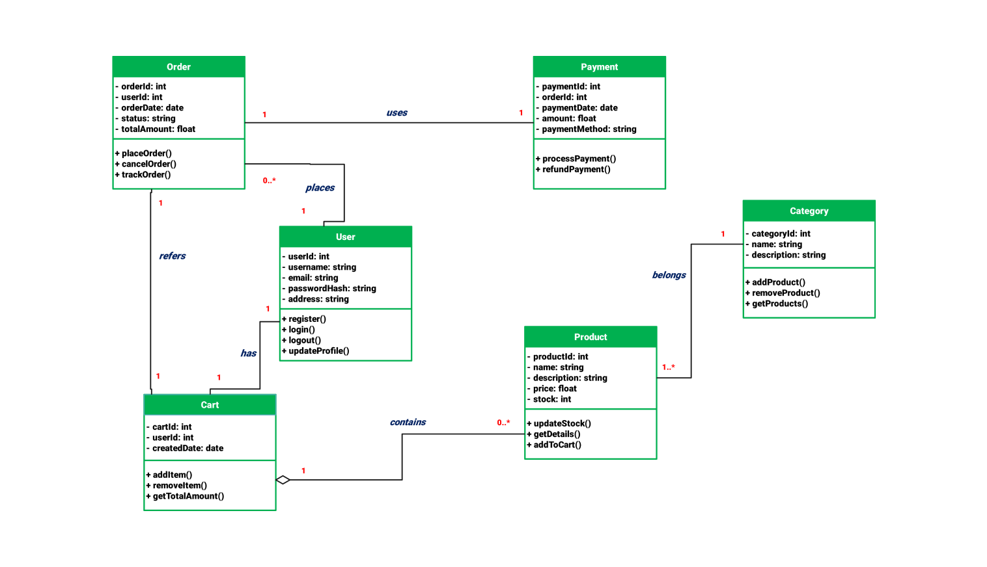

**ER Diagram:**

